Society Member Access to the journal, Legal Medicine

Instructions for the Members of the Japanese Society of Legal Medicine

To activate access to this new Society Site, and to create your personal account on ScienceDirect, you will need to use your Society Membership Number.

Please enter your Society Membership Number in the Registration Box at the following URL: https://www.sciencedirect.com/science/activate/legalmed

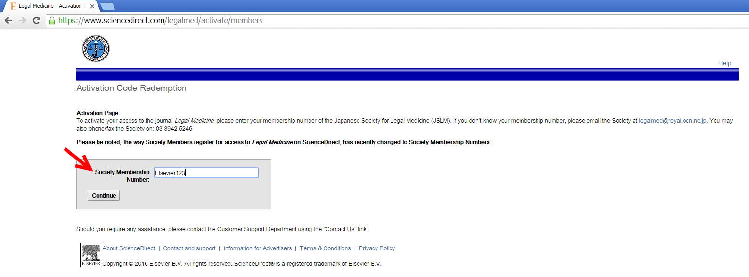

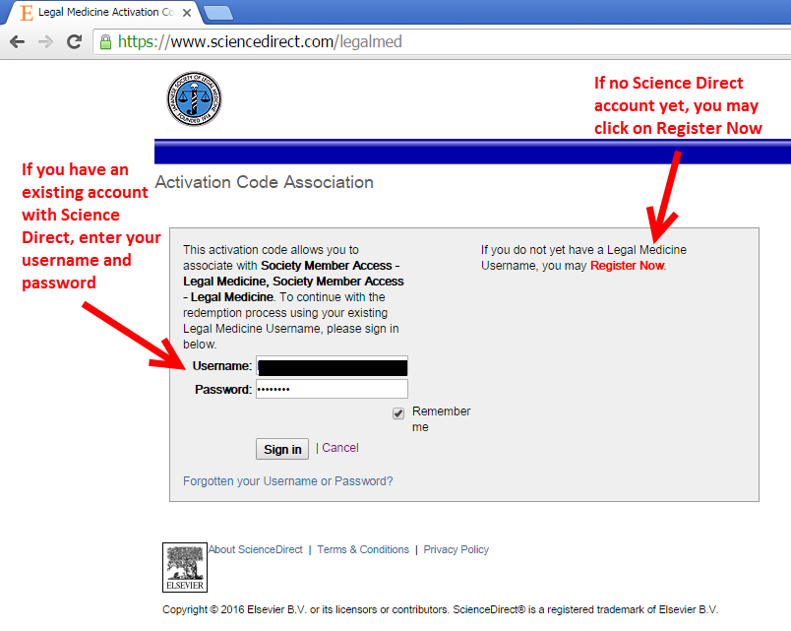
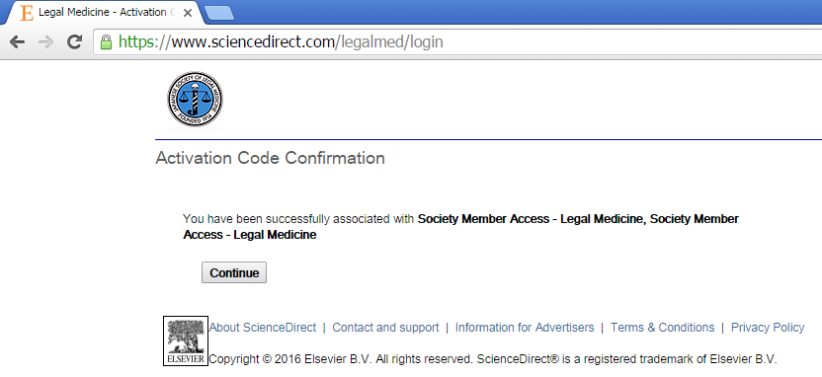

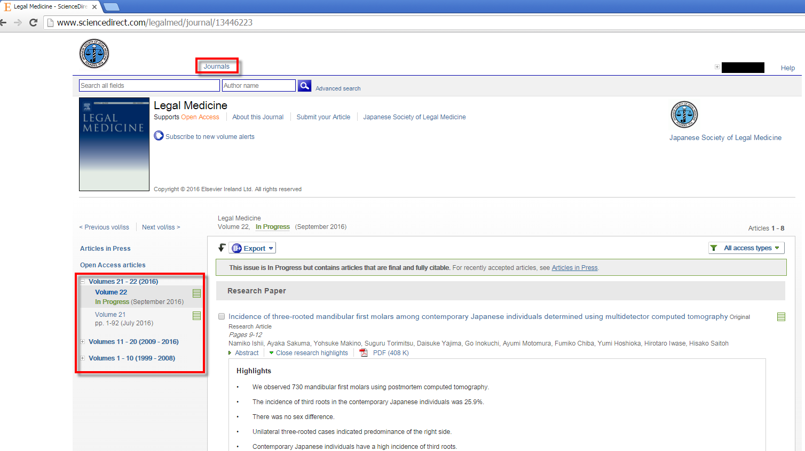

If you don’t know your Society Membership Number (or have forgotten it), please can you contact the Japanese Society of Legal Medicine:
Tel / Fax 03-3942-5246: E-mail: legalmed@royal.ocn.ne.jp

It is important to note, that all user-names and passwords to ScienceDirect are case sensitive.

Please Note: “https: //” MUST be entered for this URL – “http://” will not work. This is to ensure that your registration details are secured in our Customer Service System when you enter them into the registration form.

Please Note - Do NOT use special characters, such as ö, ä, æ when entering your personal details into the profile form.

After entering, click on "submit". The next step is completing a user profile. You will be asked to fill out a form and choose a password. An unique username will be assigned.

After registration you can directly login with your new username and password. Please go to your Society Members Site and enter your username and password in the upper-right hand corner of the Homepage via the following URL:http://www.sciencedirect.com/science/journal/13446223

Please enter your personal username and password in the login bar on the top of the page.

If you encounter any problems registering, please note that older browsers may not support SSL encryption, which is required for secure data transmission. Also, cookies must be enabled in your browser to support the registration process.

Instructions for the Members of the Japanese Society of Legal Medicine

Please note, access to this journal on ScienceDirect, via your Society Access, is available from articles published from Volume 1, Issue 1, (1999).

Should you require any assistance, please do not hesitate to contact the closest Customer Support department as follows.

Please mention the title of the journal you are trying to access, the URL of the site and the name of your society in your communication.

Customers in North, Central, and South America should contact:  Telephone: 1-888-615-4500  (+1 212-462-1978 if calling from outside the USA and Canada)  Fax: +1 212-633-3680  E-mail: usinfo@elsevier.com | Customers in Europe, The Middle East and Africa should contact:  Telephone: +31 20 485 3767  Fax: +31 20 485 3432  E-mail: nlinfo@elsevier.com
Customers in Asia Pacific including Australia (except Japan) should contact:  Telephone: +65 6349 0222  Fax: (+63) 2352 1394  E-mail: sginfo@elsevier.com | Customers in Japan should contact:  Telephone: +81 3 5561 5035  Fax: +81 3-5561-5047  E-mail: jpinfo@elsevier.com

